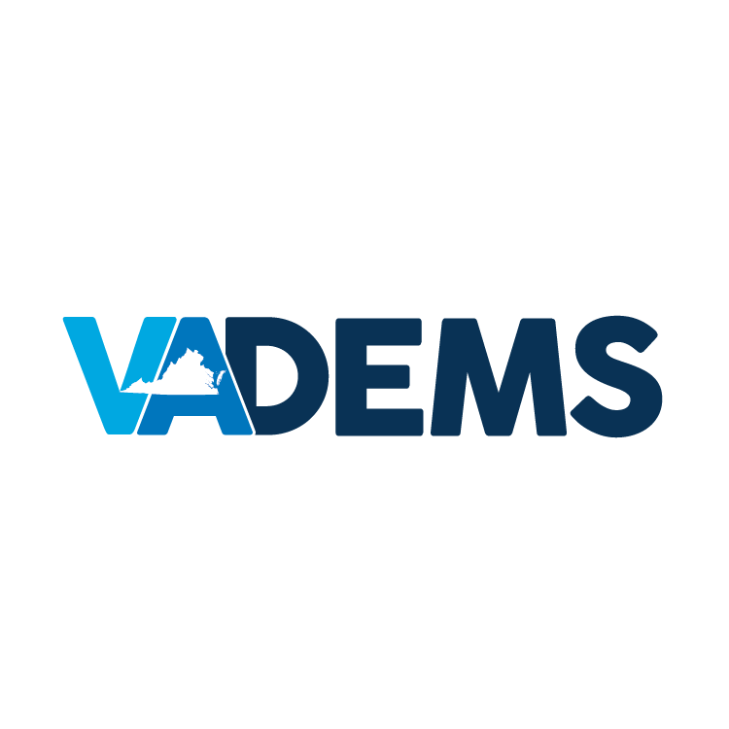

DEMOCRATIC PARTY OF VIRGINIA
FINANCIAL OVERVIEW: FEBRUARY 2016

PREPARED FOR:
DPVA BUDGET COMMITTEE

PREPARED BY:
TOM BUNEO, DEPUTY EXECUTIVE DIRECTOR & COO
BRITTNE WALKER, OPERATIONS DIRECTOR

