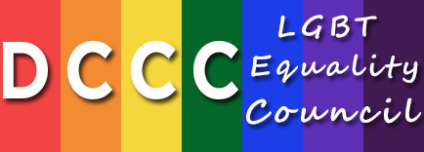
Hon. Jared Polis, LGBT Equality Council Chair

2015 Schedule of Events

March 2015
DCCC Santa Fe Issues Conference

May 2015
LGBT Equality Council Conference Call

June 2015
New York City Planning Breakfast
Washington, DC Signature Event

August 2015
LGBT Equality Council Conference Call
DCCC Speaker’s Cabinet Napa Valley Issues Conference

September 2015
New York City Signature Event

November 2015
LGBT Equality Council Conference Call

For further information, please contact Adam Blackwell at (202) 485-3450 or by email at blackwell@dccc.org.

Paid for by the Democratic Congressional Campaign Committee.
430 South Capitol Street, S.E. – Washington, D.C. 20003– 202.863.1500 – www.DCCC.org
Not authorized by any candidate or candidate’s committee.

